1. **Install ElasticSearch (and Kibana), and install Nifi on a Centos or Ubuntu VM**

**INSTALL ELASTICSEARCH**

**Import the Elasticsearch PGP Key**

1. wget -qO - https://artifacts.elastic.co/GPG-KEY-elasticsearch | sudo gpg --dearmor -o /usr/share/keyrings/elasticsearch-keyring.gpg

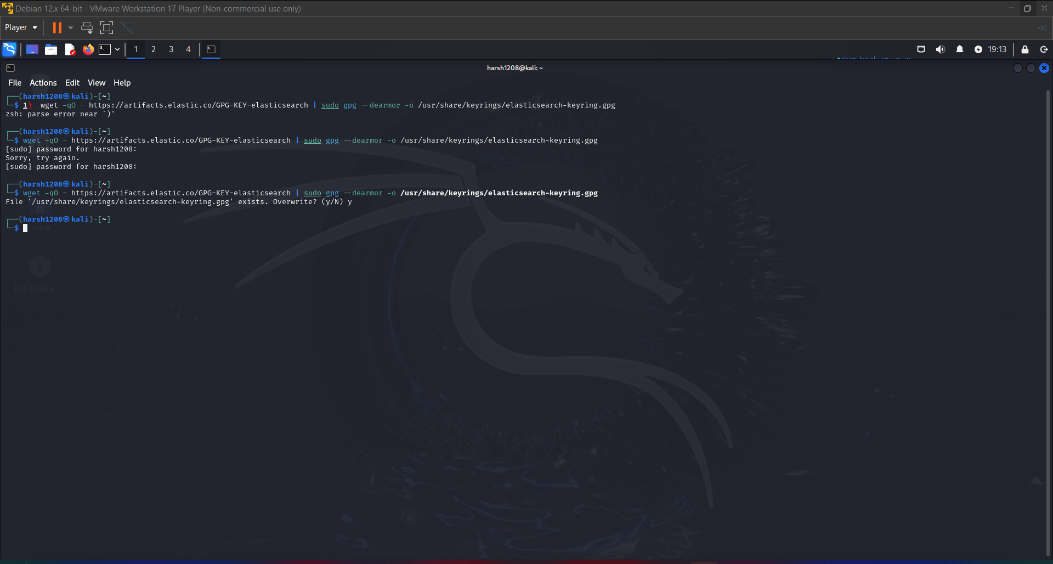

**Installing from the APT repository**

1. sudo apt-get install apt-transport-https

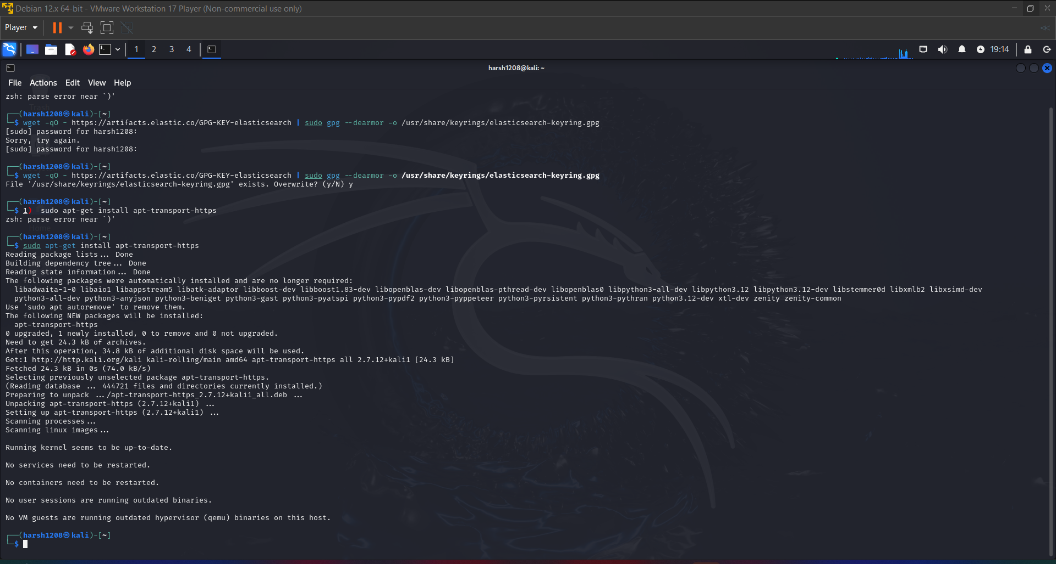

1. echo "deb [signed-by=/usr/share/keyrings/elasticsearch-keyring.gpg] https://artifacts.elastic.co/packages/8.x/apt stable main" | sudo tee /etc/apt/sources.list.d/elastic-8.x.list

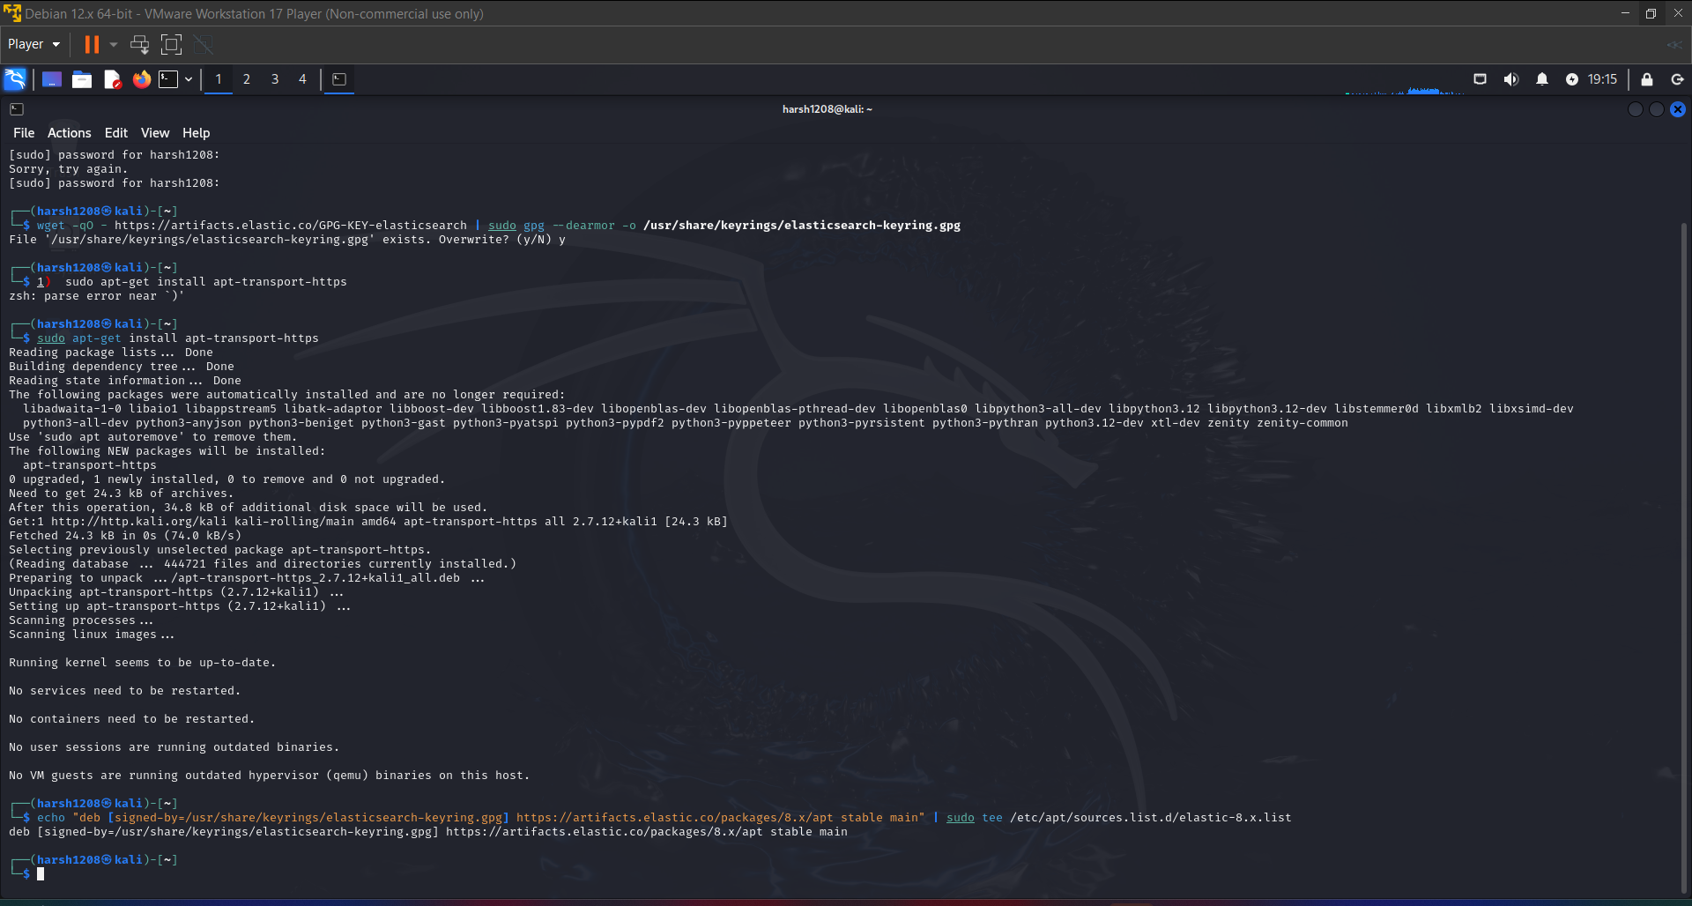

1. sudo apt-get update && sudo apt-get install elasticsearch

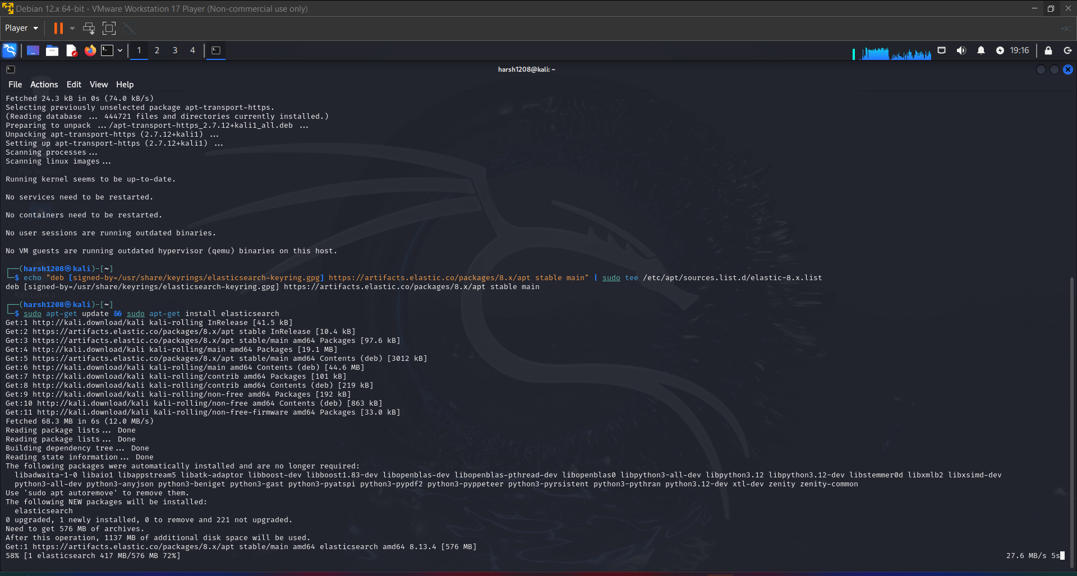

**Running Elasticsearch with systemd**

sudo /bin/systemctl daemon-reload

sudo /bin/systemctl enable elasticsearch.service

Elasticsearch can be started and stopped as follows:

sudo systemctl start elasticsearch.service

sudo systemctl stop elasticsearch.service

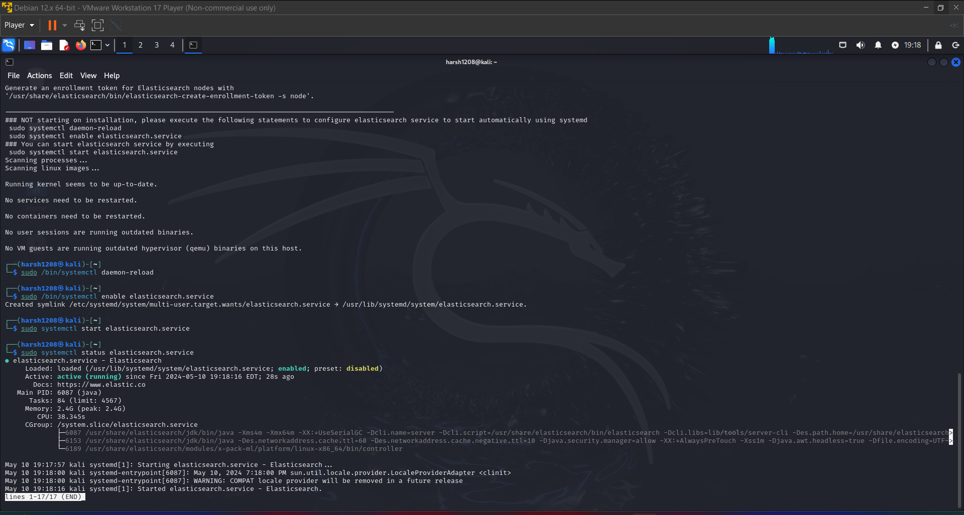

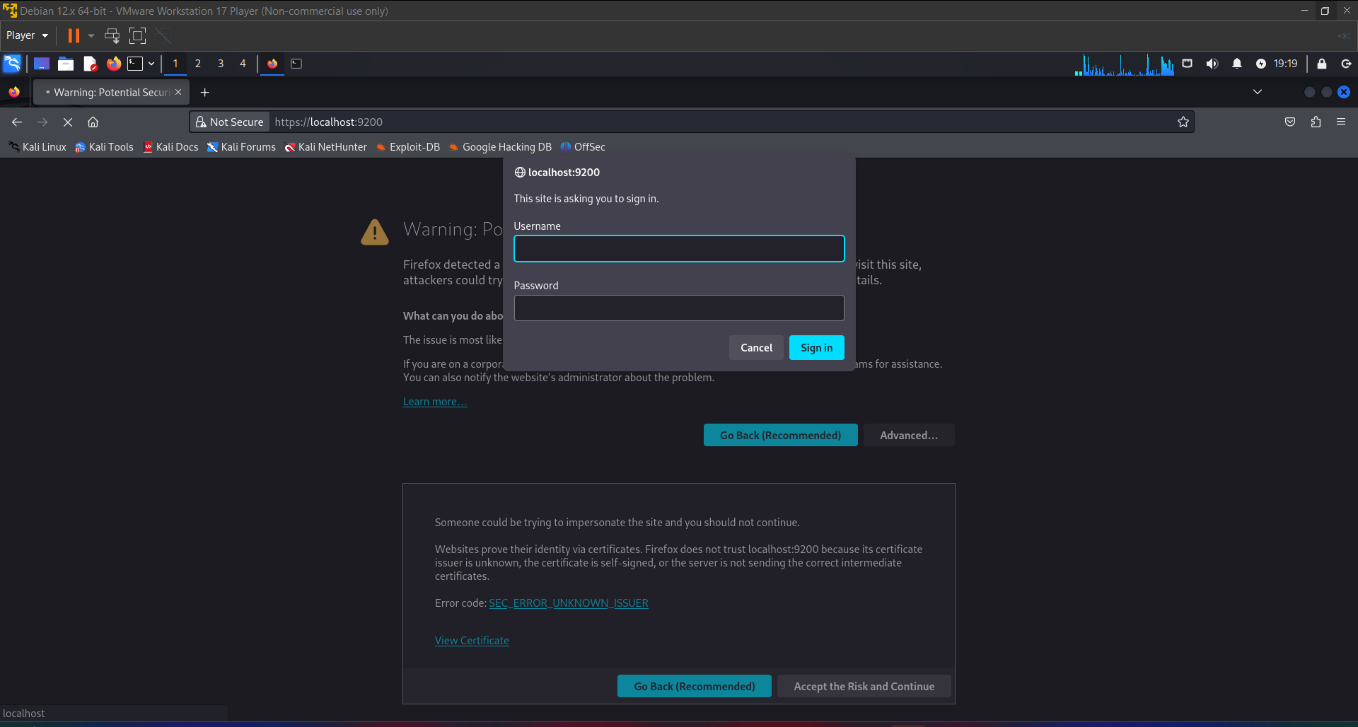

Start Elasticsearch without username and password (disable security settings):

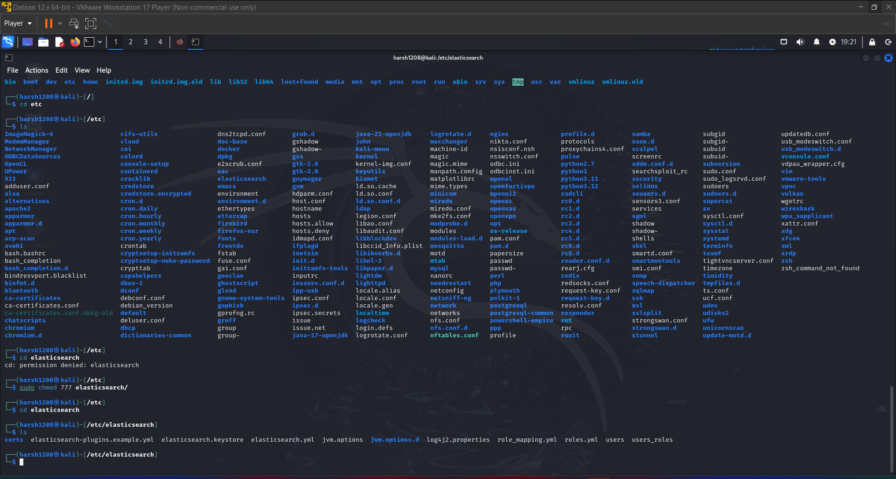

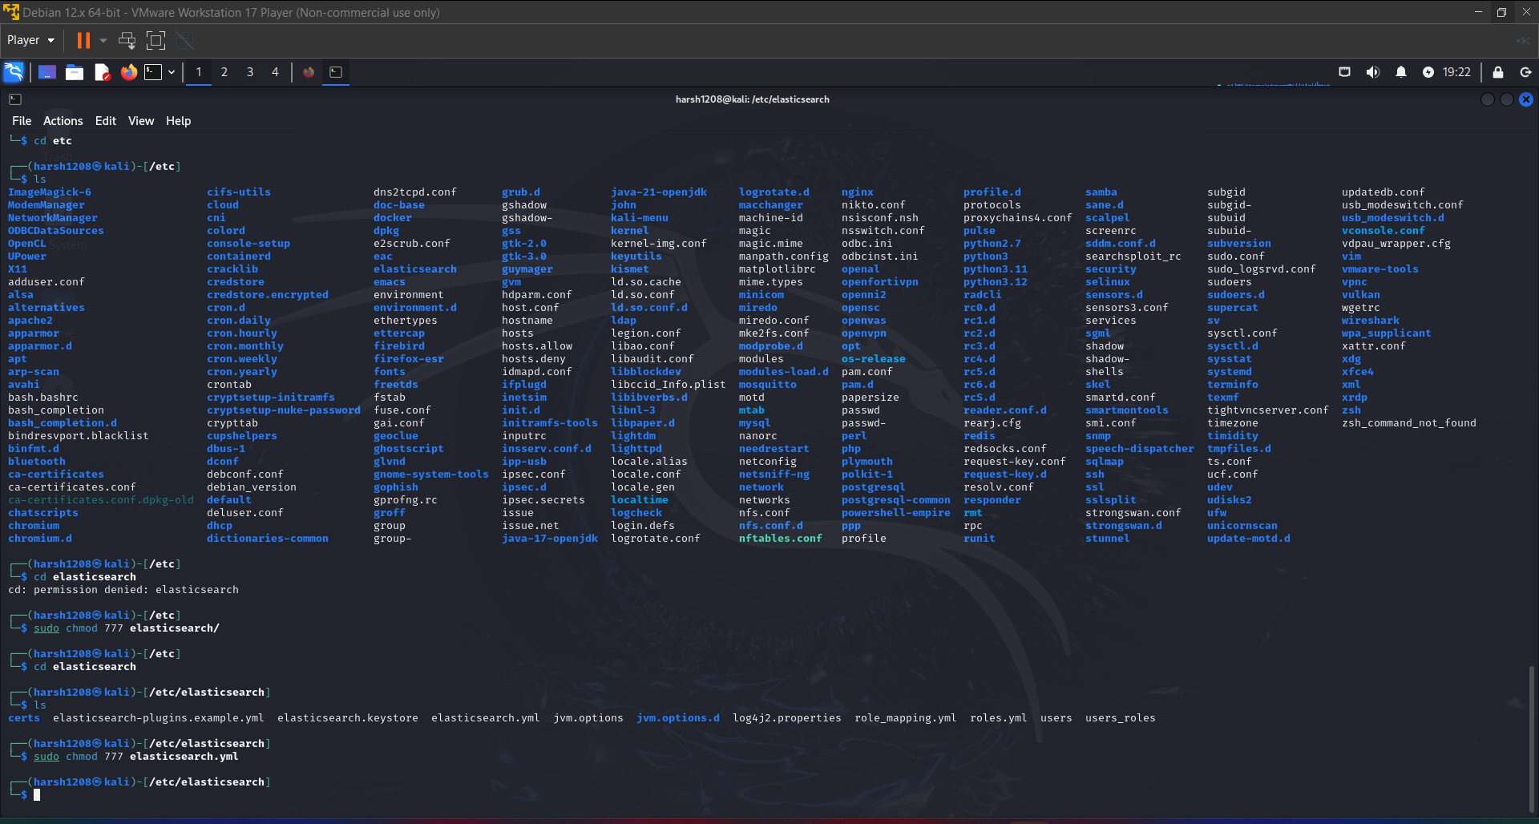

Open yml file

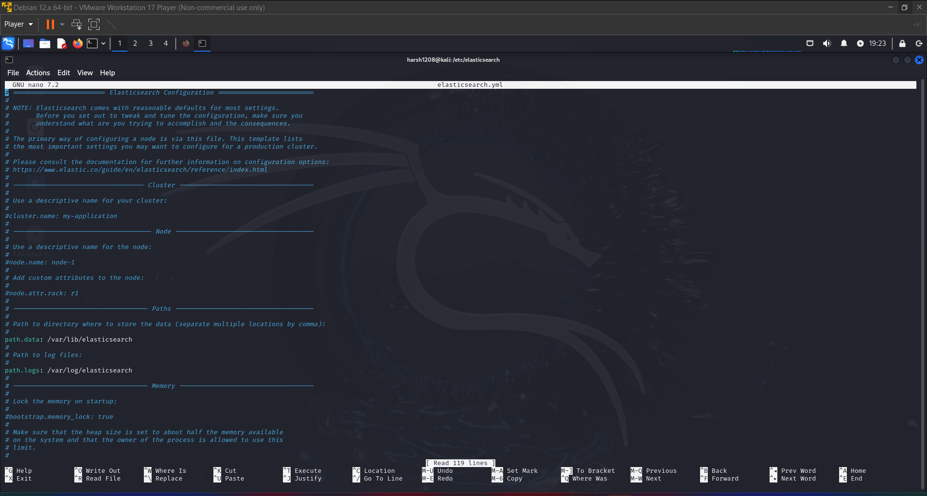

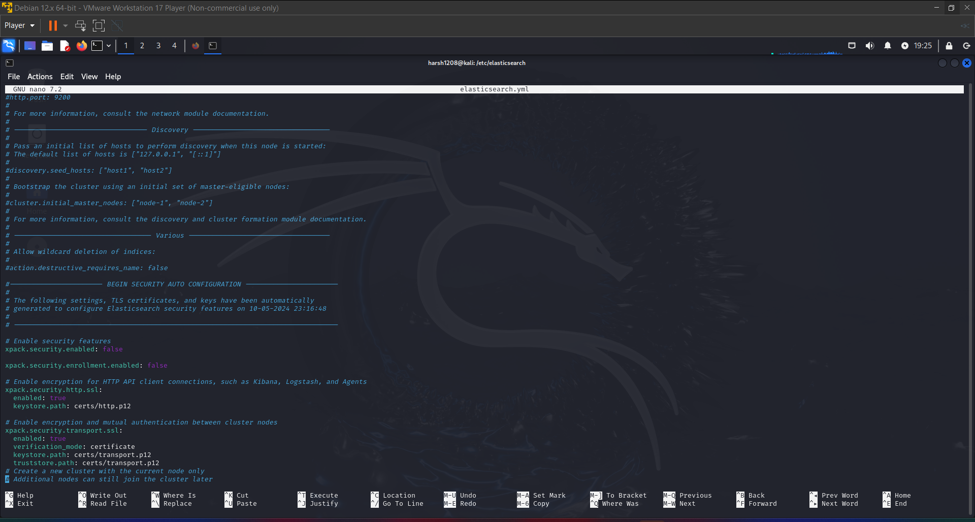

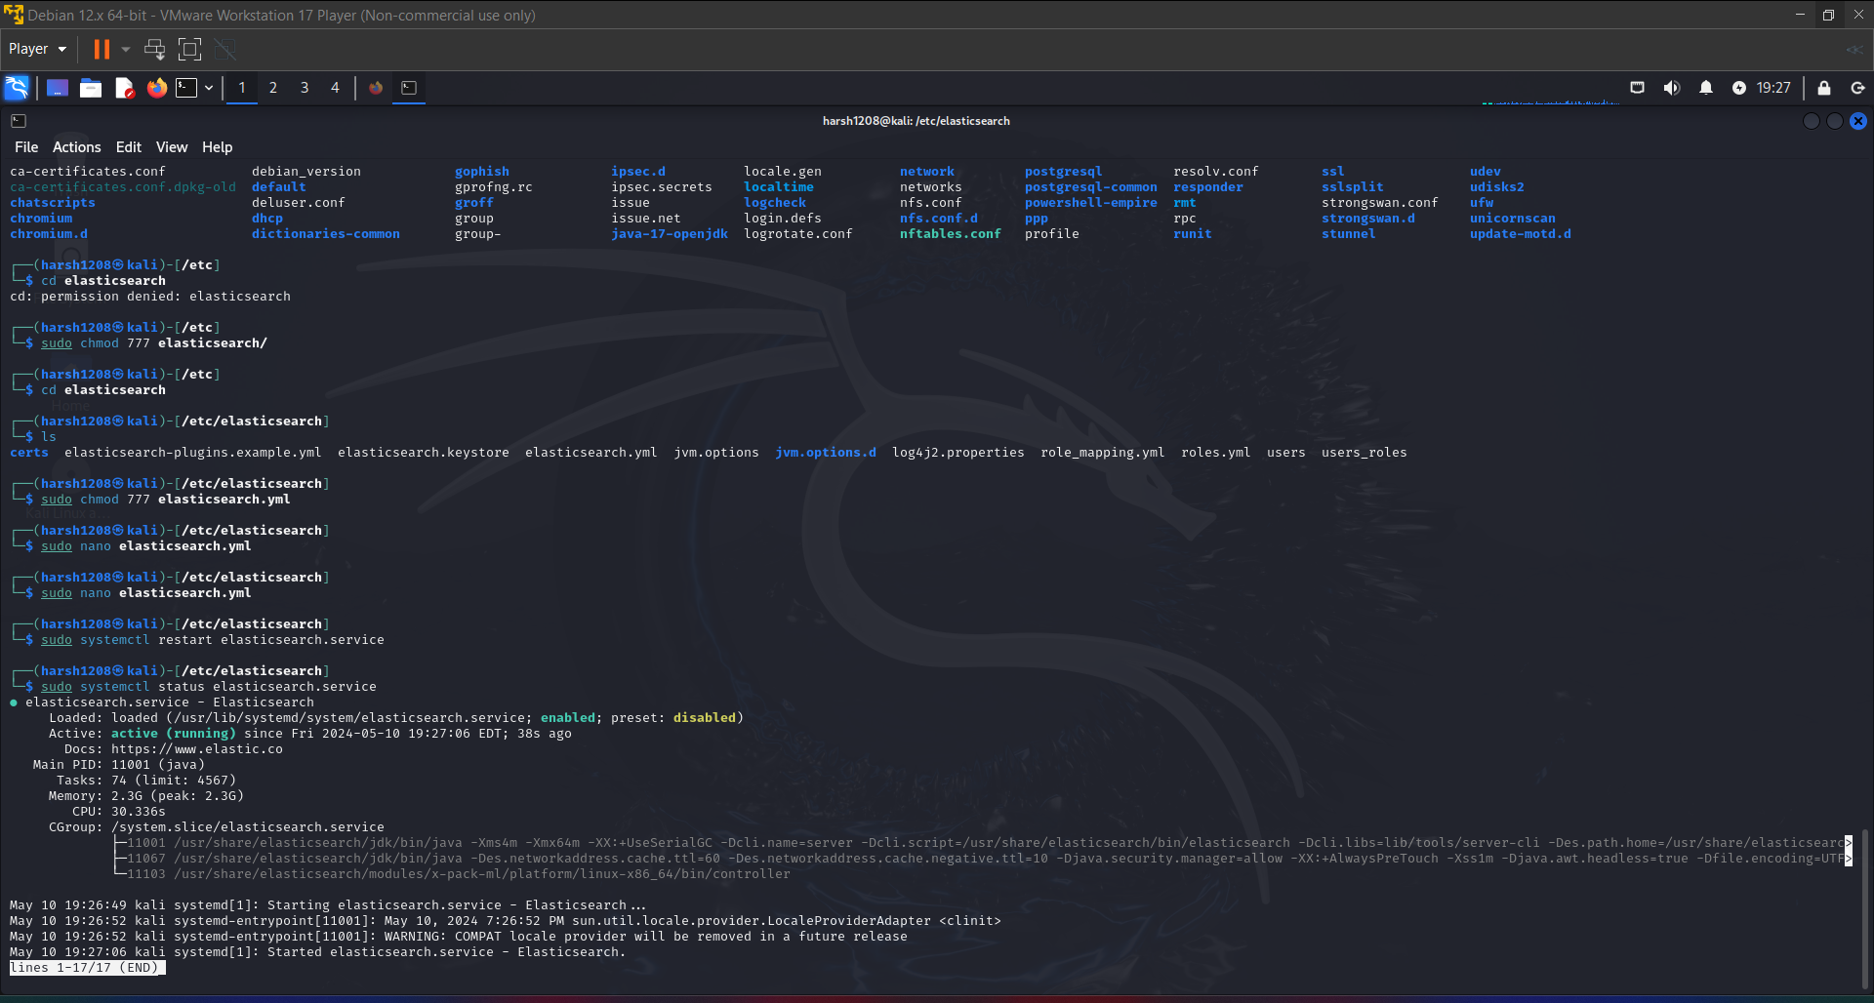

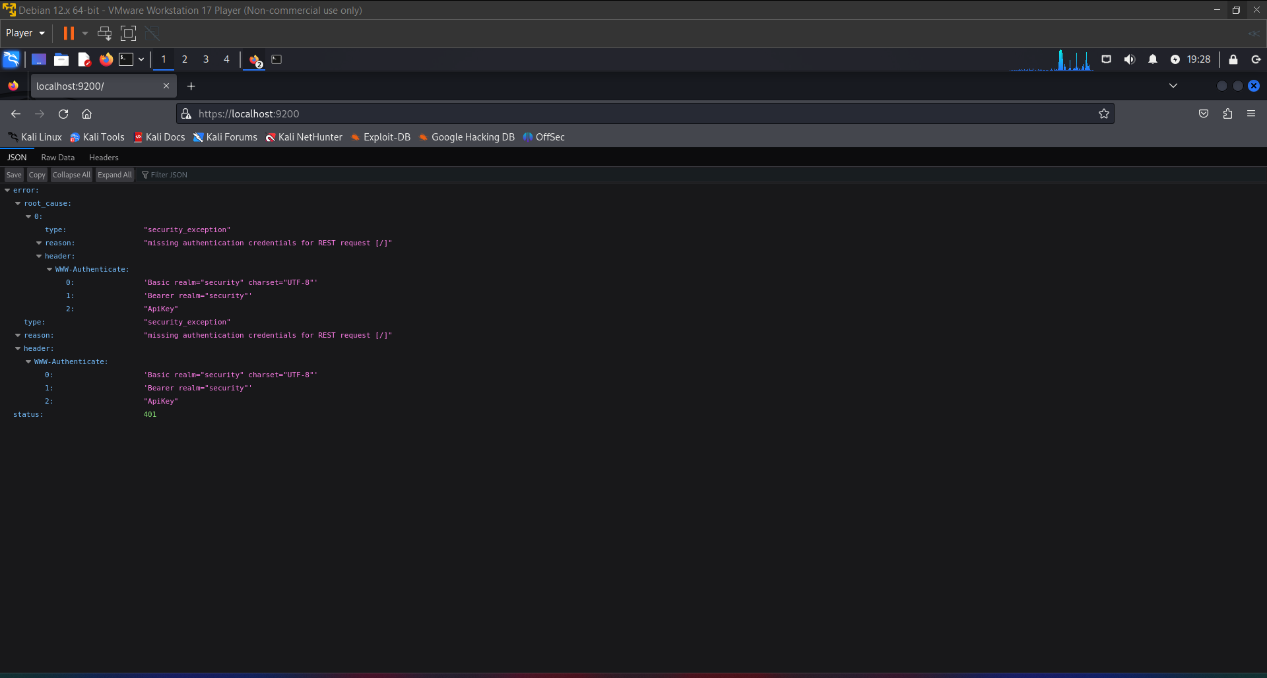

**INSTALL KIBINA**

Download Kibana at:

**Import the Elastic PGP key**

1. wget -qO - https://artifacts.elastic.co/GPG-KEY-elasticsearch | sudo gpg --dearmor -o /usr/share/keyrings/elasticsearch-keyring.gpg

**Install from the APT repository**

1)sudo apt-get install apt-transport-https

2)echo "deb [signed-by=/usr/share/keyrings/elasticsearch-keyring.gpg] https://artifacts.elastic.co/packages/8.x/apt stable main" | sudo tee /etc/apt/sources.list.d/elastic-8.x.list

**You can install the Kibana Debian package with:**

sudo apt-get update && sudo apt-get install kibana

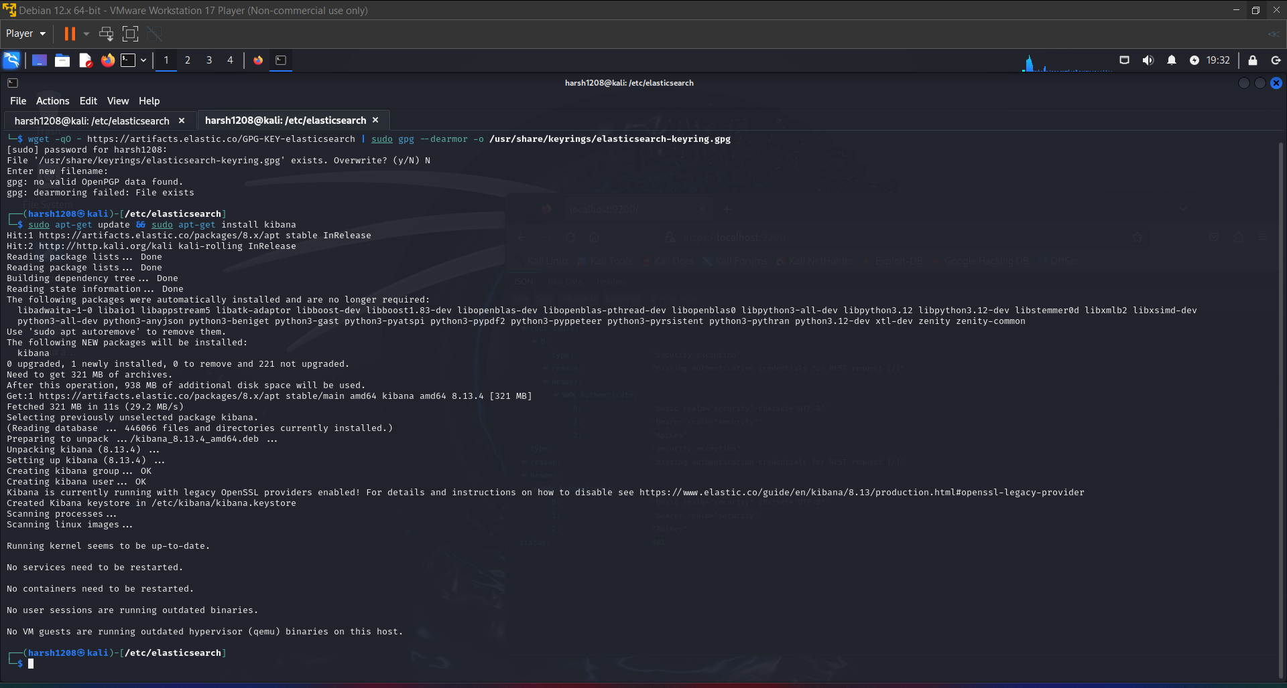

**Run Kibana with system**

sudo /bin/systemctl daemon-reload

sudo /bin/systemctl enable kibana.service

sudo systemctl start kibana.service

sudo systemctl stop kibana.service

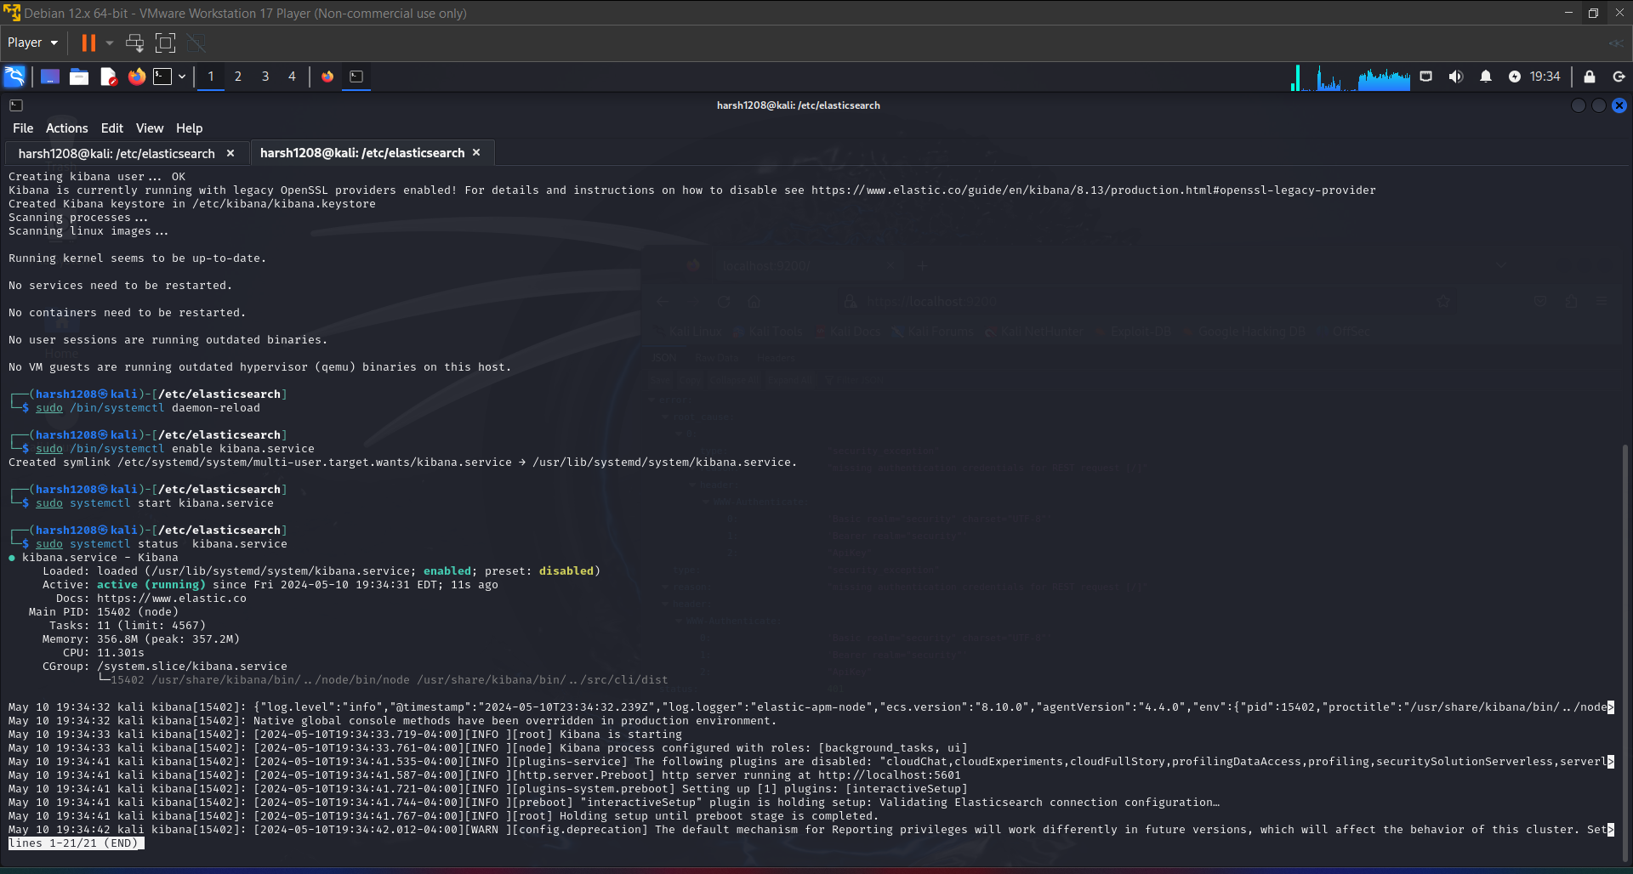

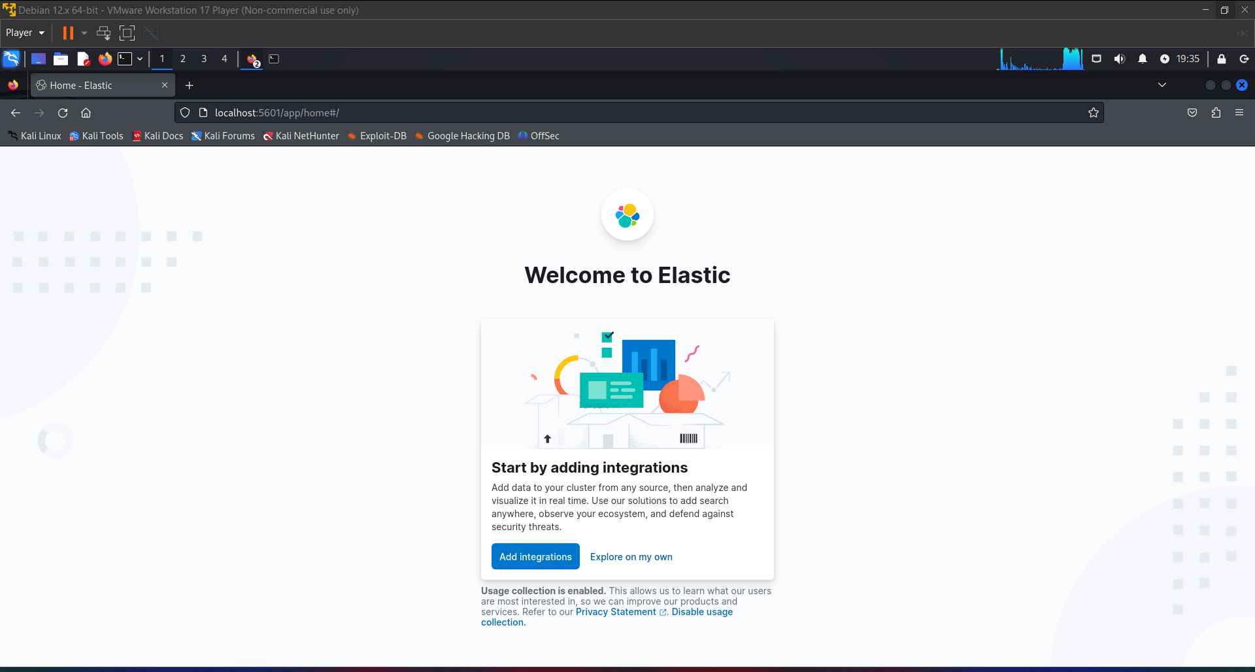

Create Index

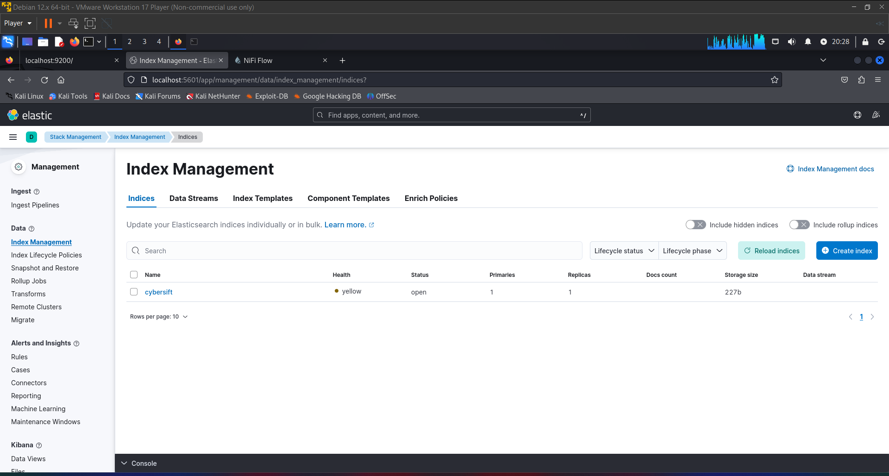

**Install Apache Nifi**

Install java:

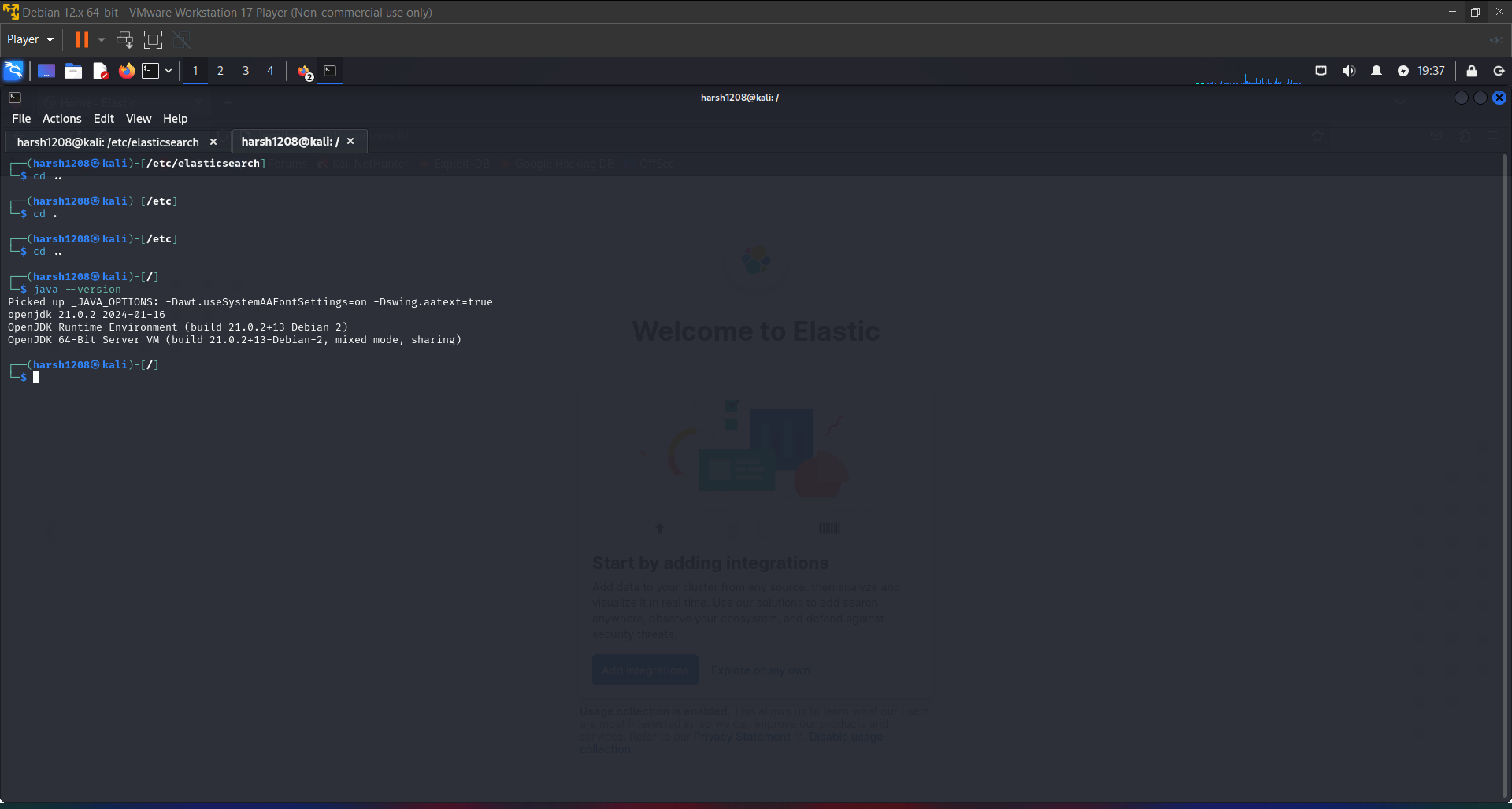

WGET NIFI

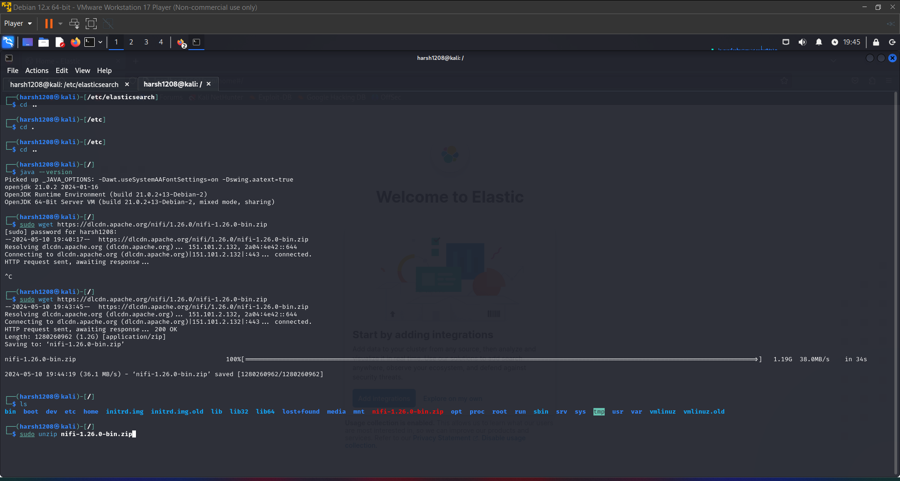

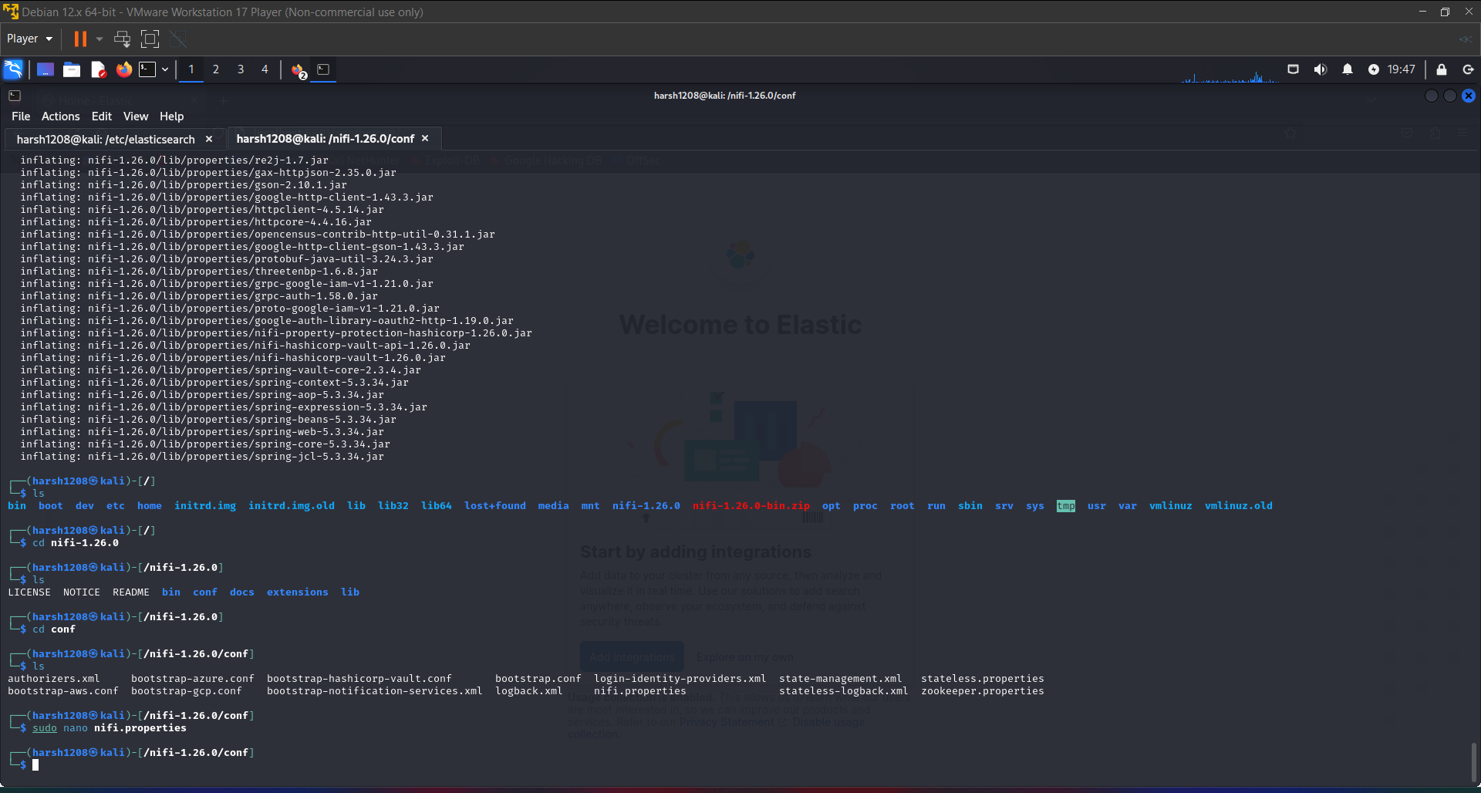

sudo bin/nifi.sh start

cat logs/nifi-app.log

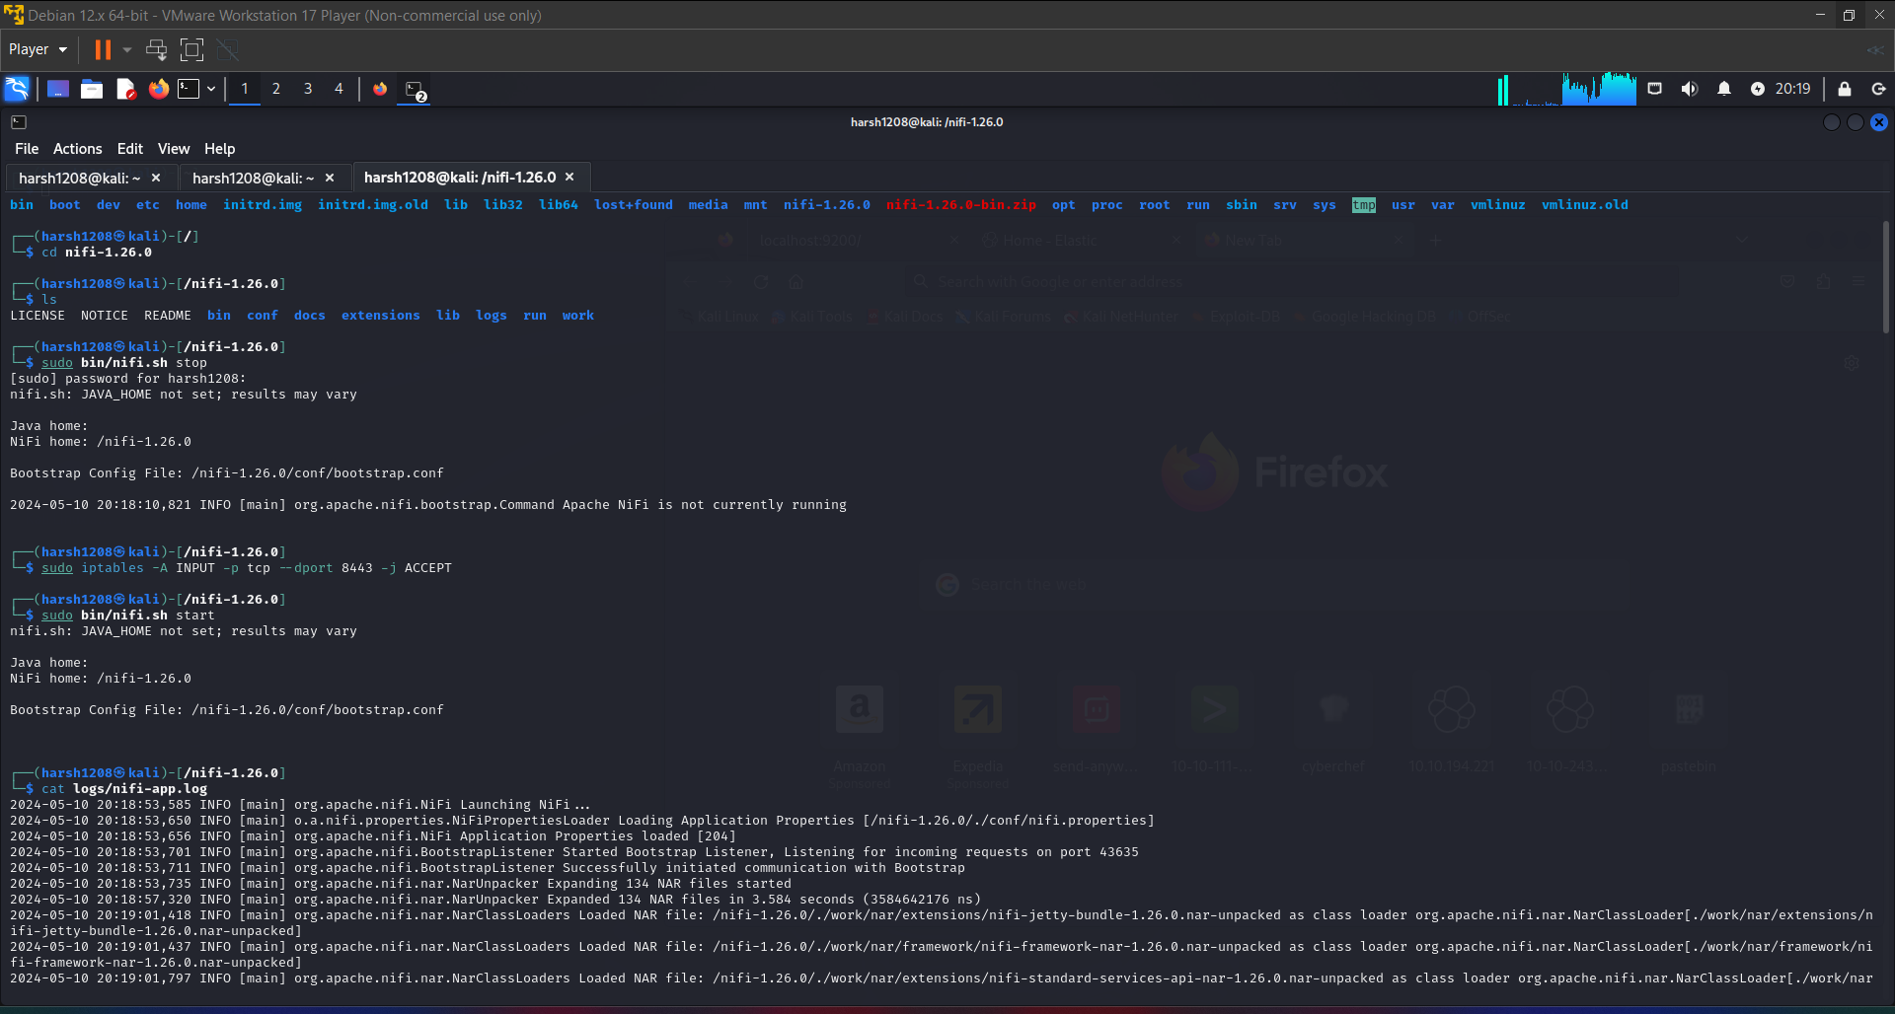

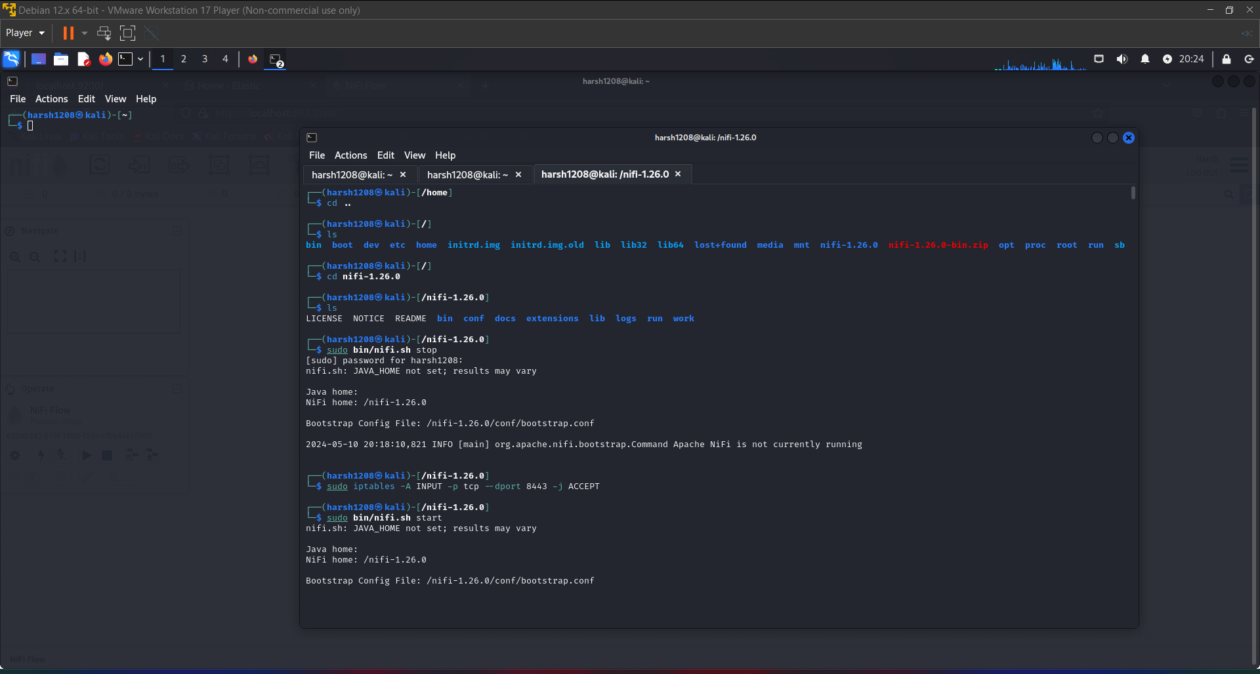

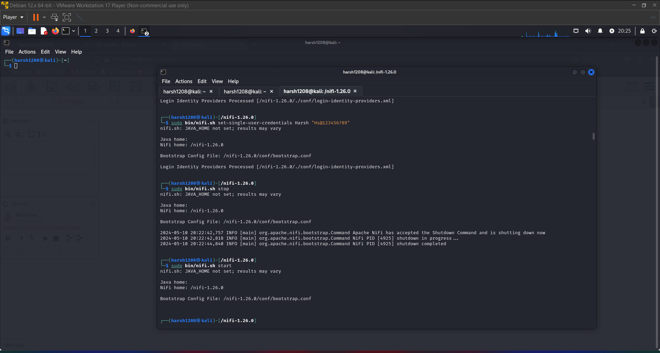

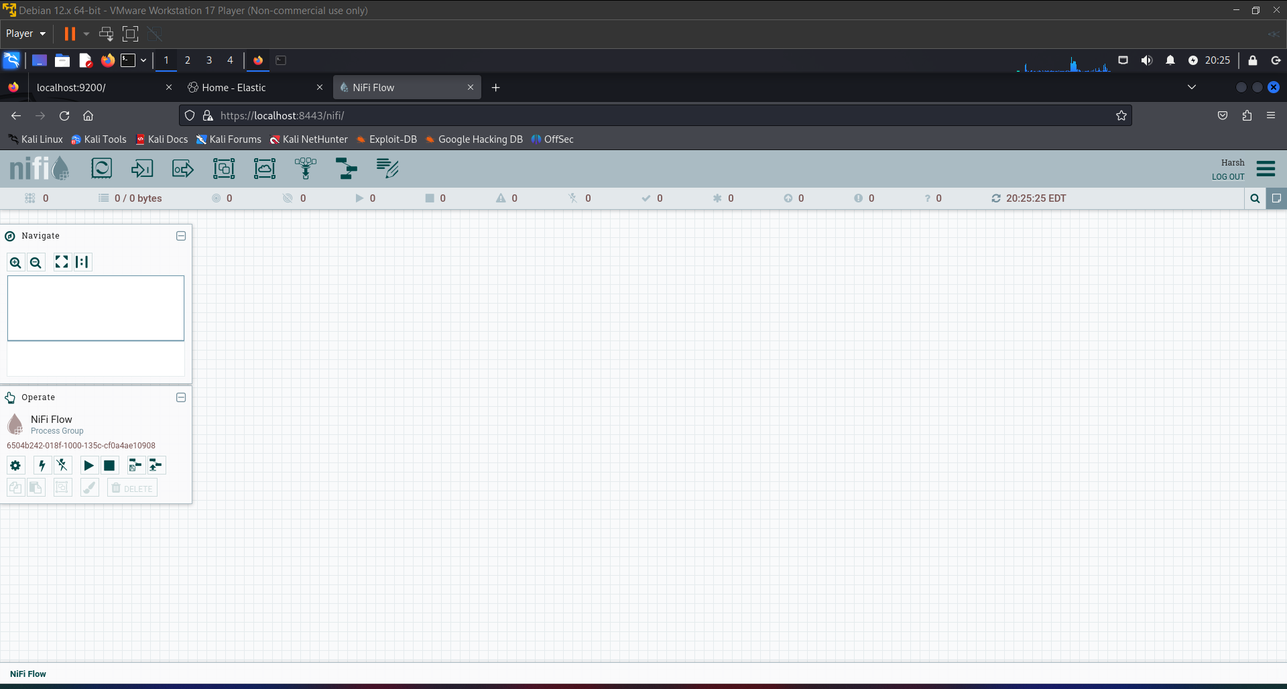

1. Build a simple NiFi pipeline which accept syslog on local port UDP 514 and send it on to ElasticSearch

Create a Process Group name Syslog to Elasticsearch:

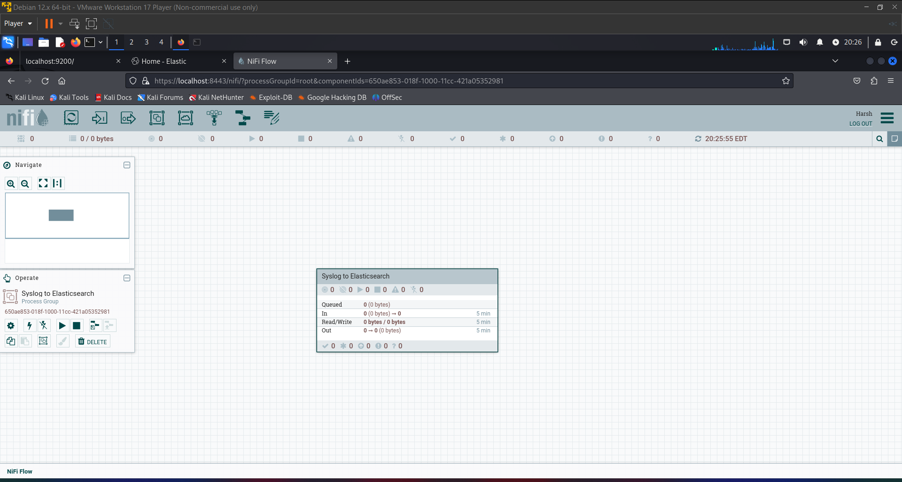

1. Set Up Syslog UDP Source

First, you need a processor to receive syslog messages:

Processor: ListenUDP

Properties:

Local Network Interface: Set to the local network interface IP or keep it blank for all interfaces.

Port: 514

Max Size of Message Queue: Depending on your expected traffic (e.g., 10000).

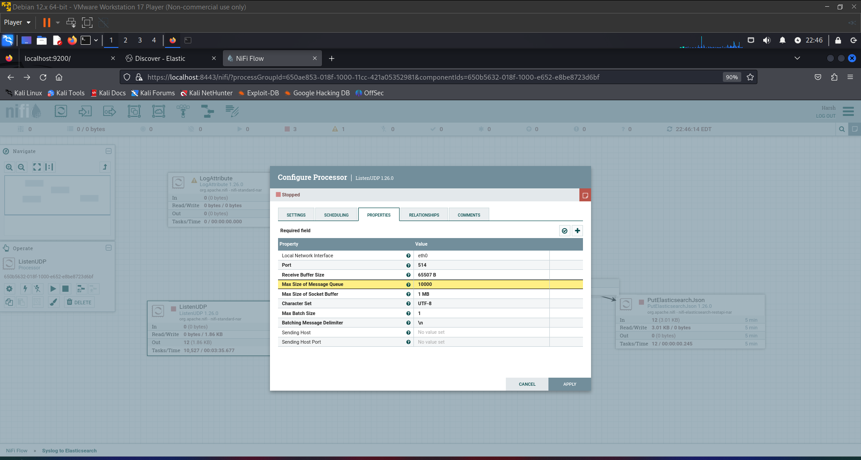

2. Convert Syslog to JSON

Syslog messages are generally not in JSON format, so you might want to convert them before sending to Elasticsearch:

Processor: ConvertRecord

Properties:

Record Reader: Use SyslogReader to parse syslog messages.

Record Writer: Use JsonRecordSetWriter to convert records to JSON.

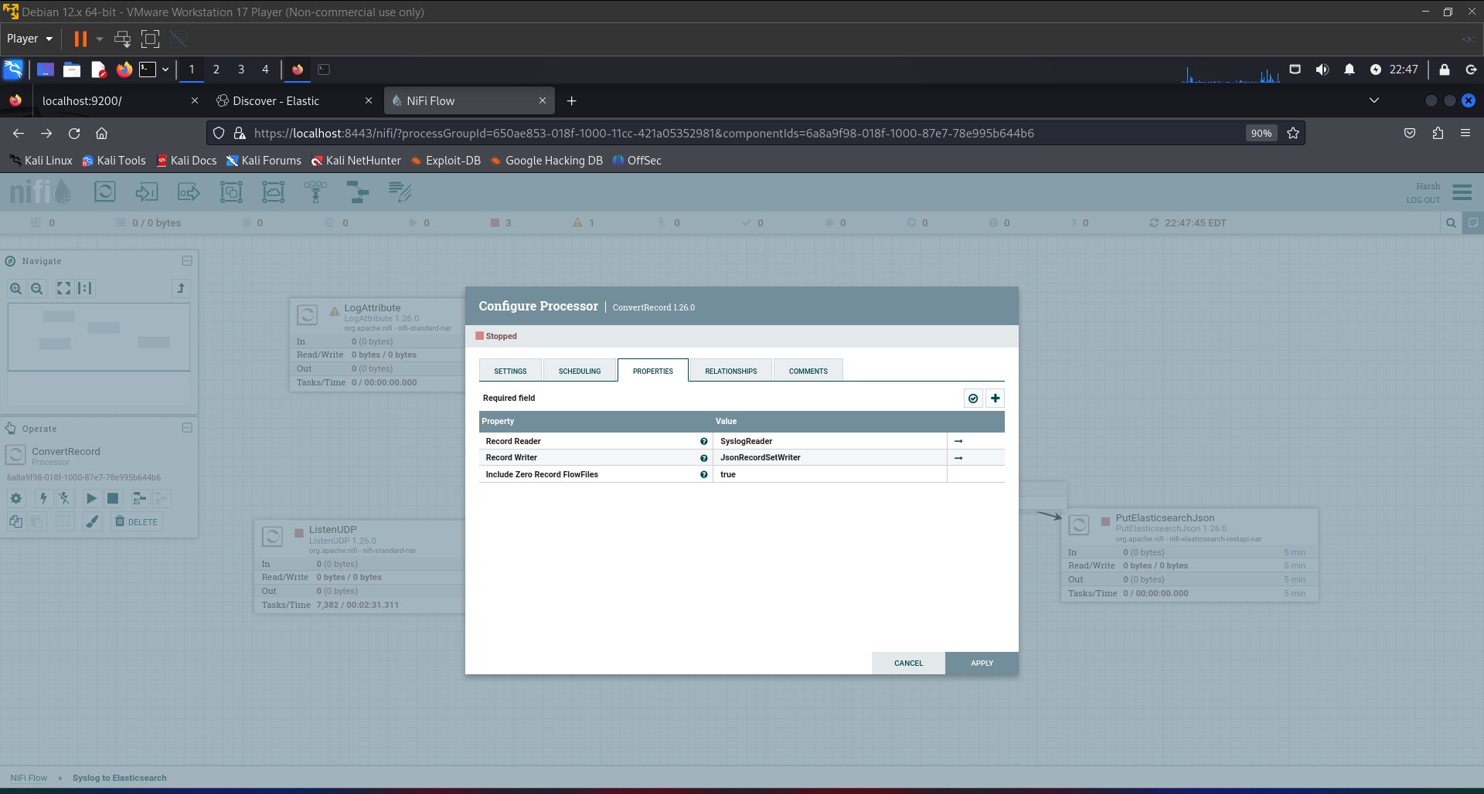

3. Send Data to Elasticsearch

Finally, use the PutElasticsearchJson processor to send the formatted syslog messages to your Elasticsearch cluster:

Processor: PutElasticsearchJson

Properties:

Elasticsearch Hosts: URL of the Elasticsearch host (e.g., http://localhost:9200).

Cluster Name: Name of your Elasticsearch cluster (if applicable).

Index: The name of the Elasticsearch index where data will be stored.

Type: The type of the index (as per Elasticsearch version).

Batch Size: Number of records to send in a batch.

ID Attribute: If you want Elasticsearch to use a specific attribute from the record as the document ID.

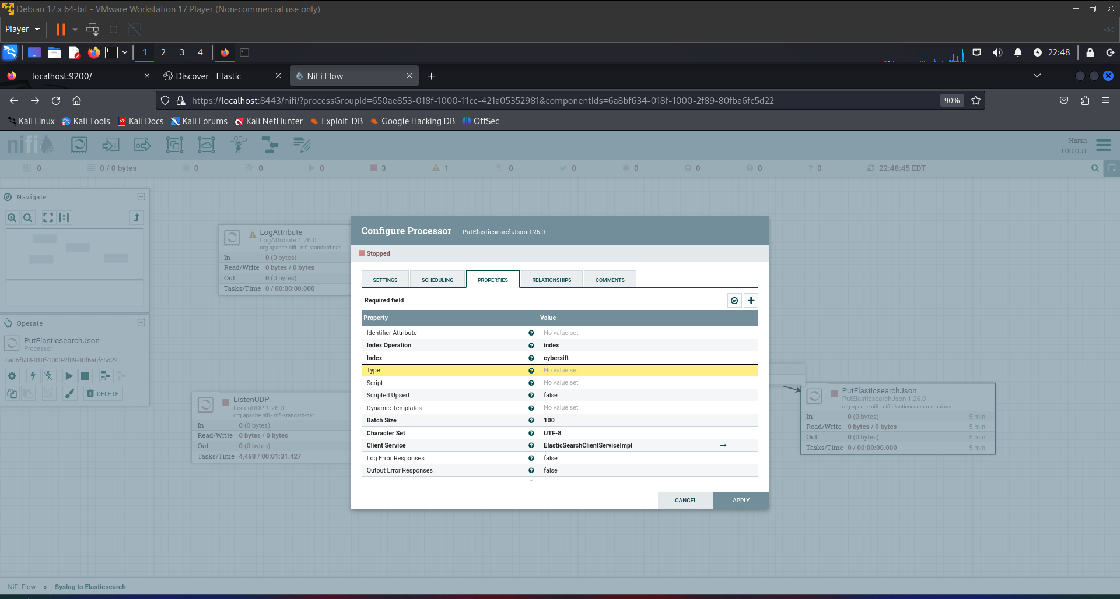

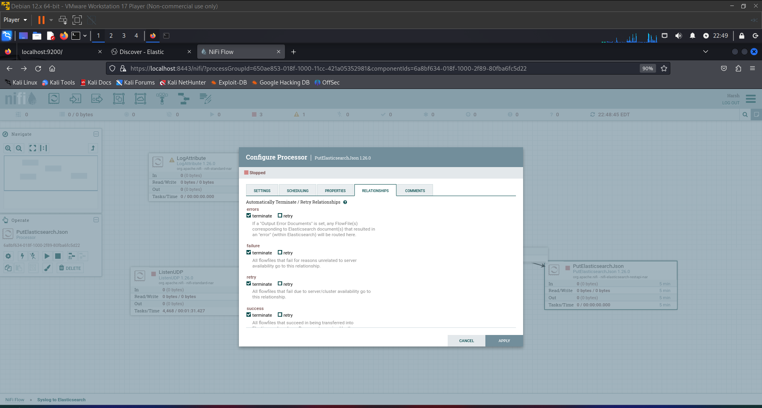

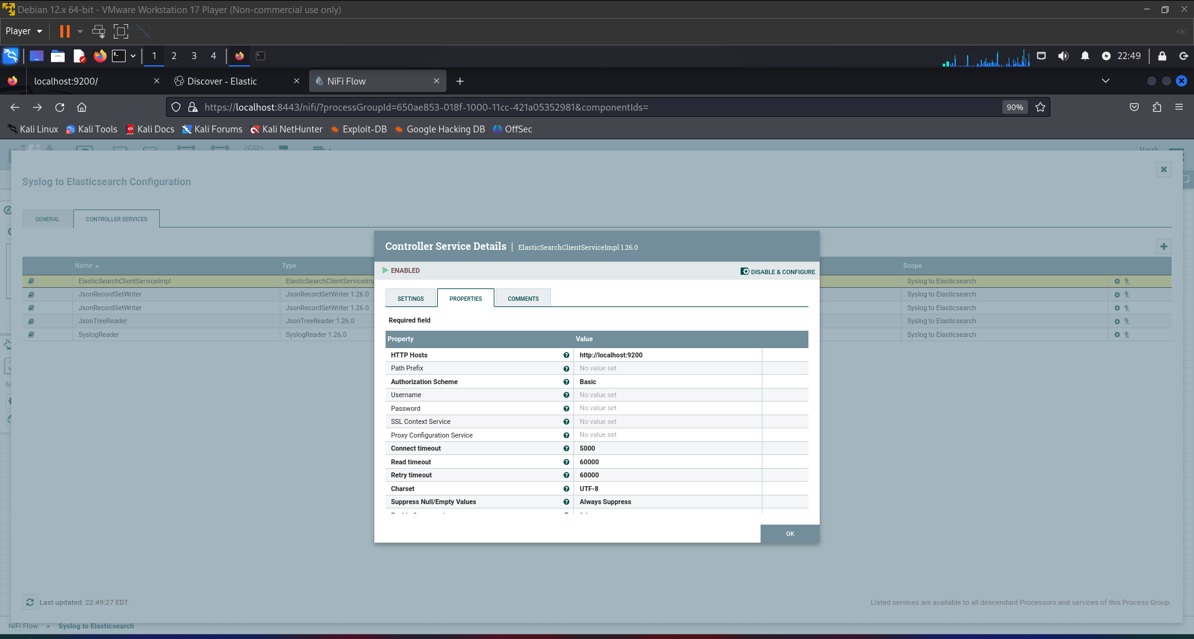

Connecting the Processors

Connect all processors:

Connect ListenUDP to ConvertRecord with a success relationship.

Connect ConvertRecord to PutElasticsearchJson with a success relationship.

Handle failure relationships according to your error-handling strategy (e.g., connect to a LogMessage processor for debugging).

Error Handling

It's good practice to add processors for handling possible errors or failed processing:

Processor: PutFile or LogMessage for debugging purposes.

Final Steps

Start the Processors: Once all configurations are done, start all the processors.

Monitor the Flow: Use NiFi’s built-in data provenance and logging to monitor the data flow and troubleshoot any issues.

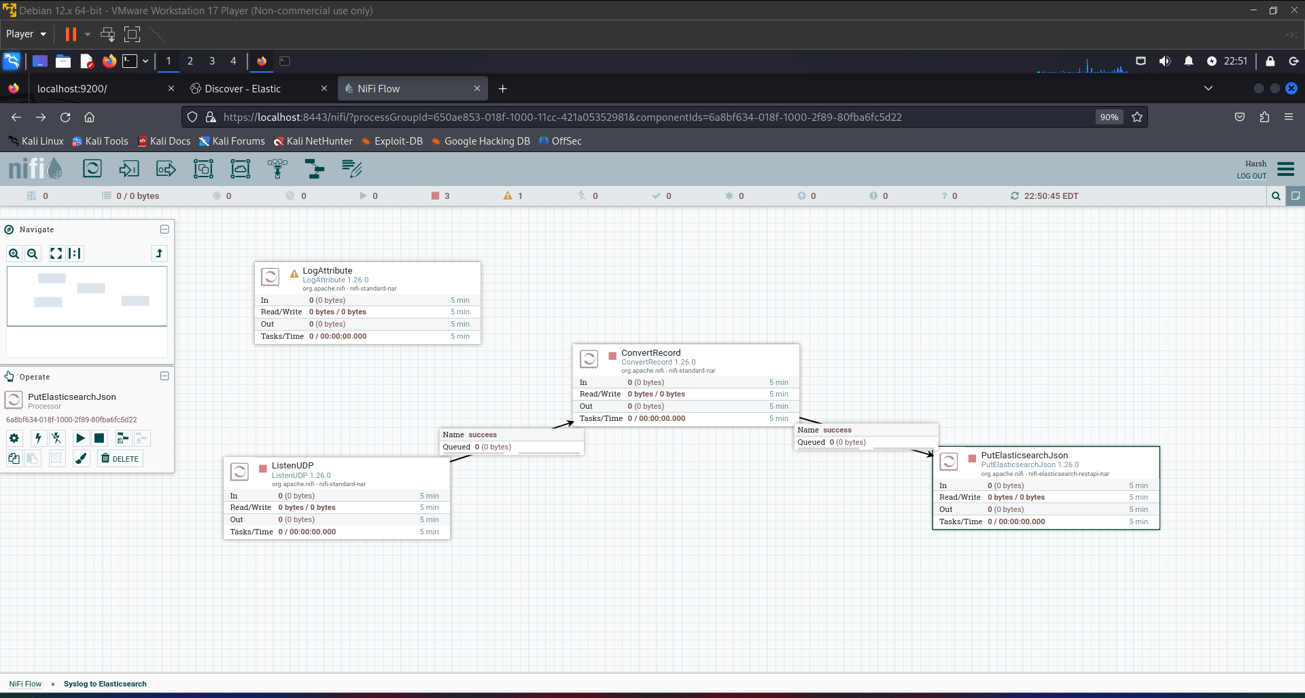

Firewall and Network Settings:

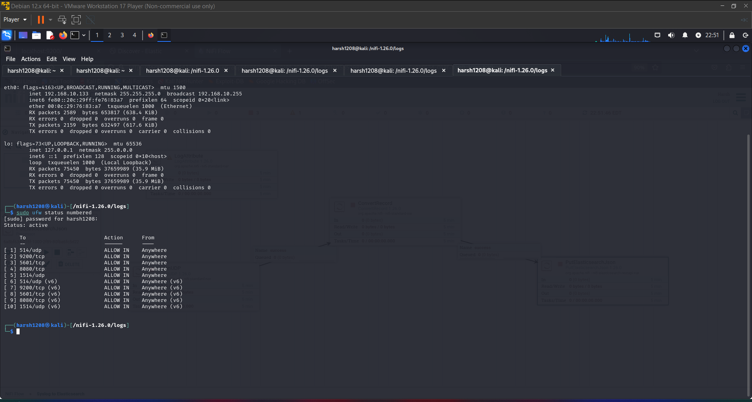

Next, Start all the Processors in NiFi and then send/generate multiple syslog messages like:

* logger -n 192.168.10.133 -P 514 -d "Test syslog message from name Kali VM"

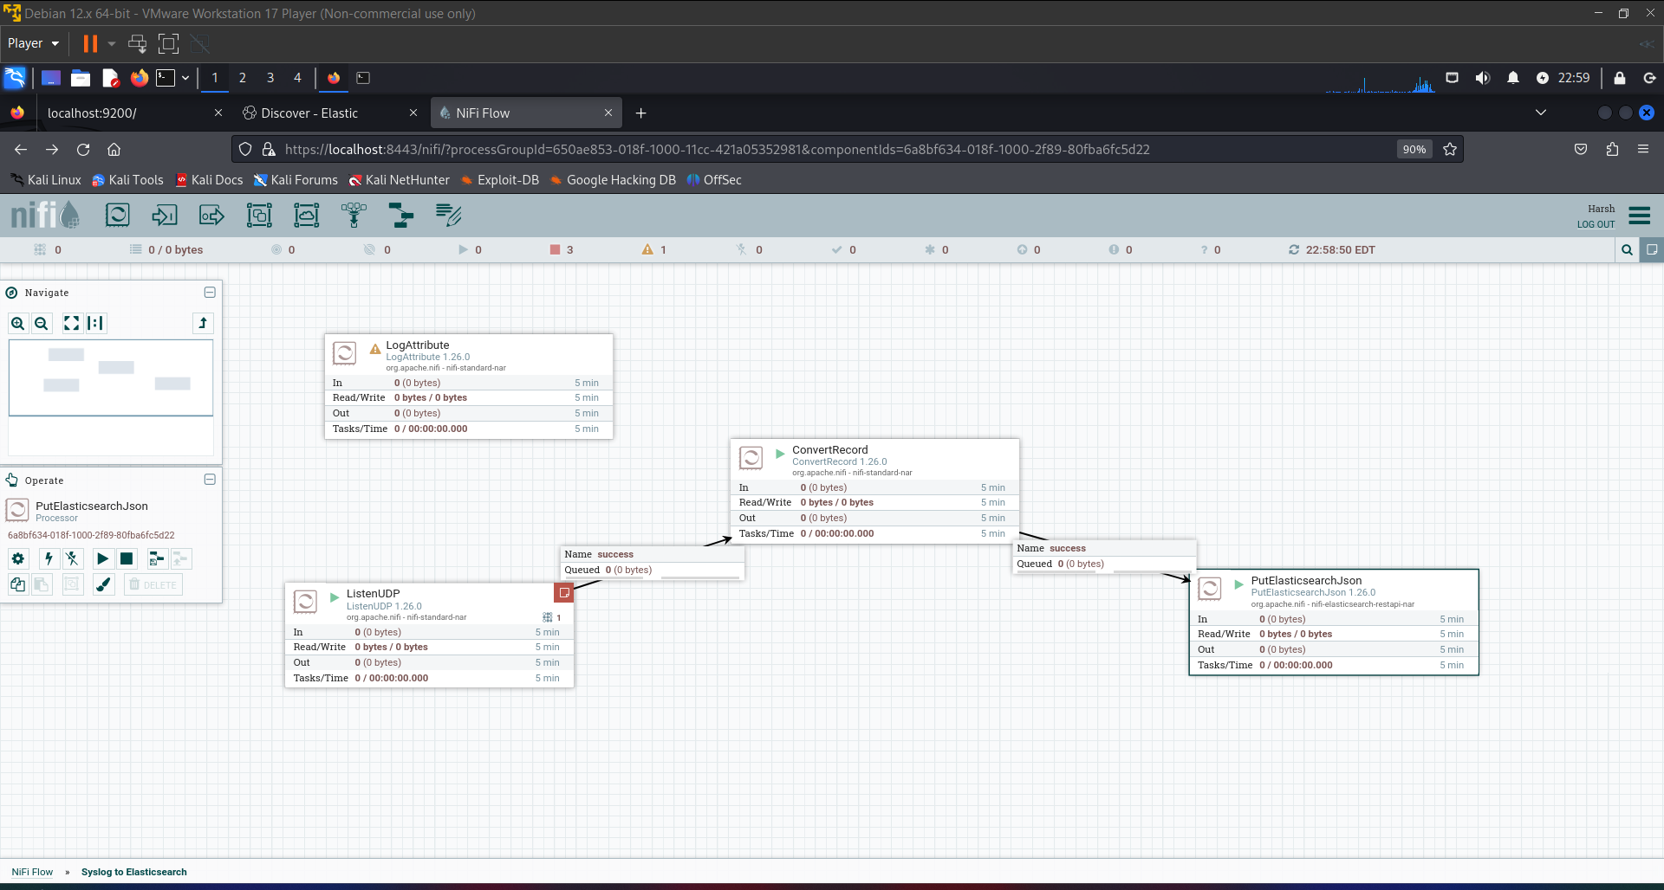

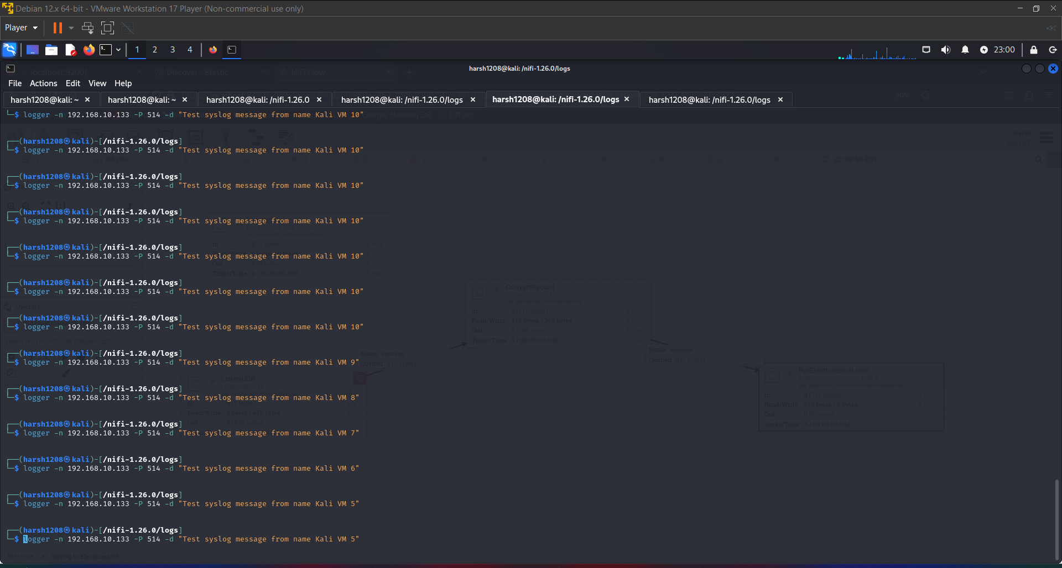

Open logs in nifi.logs and see for any errors:

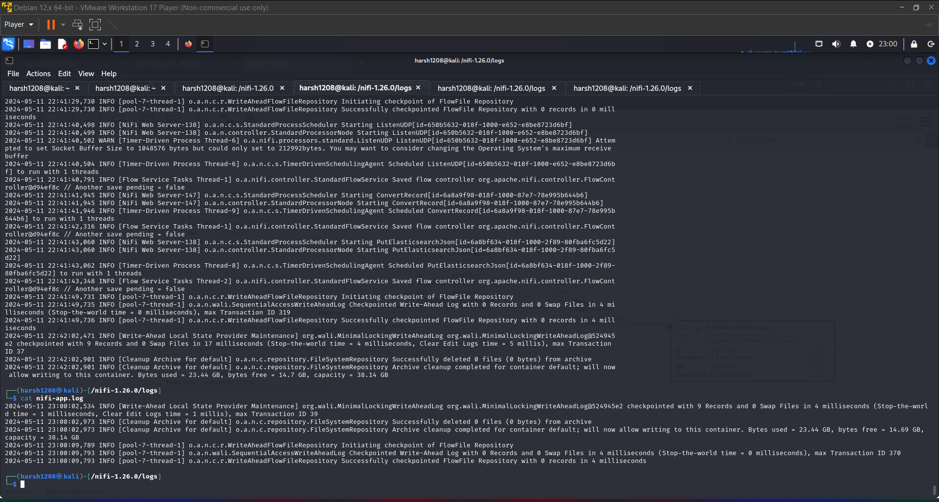

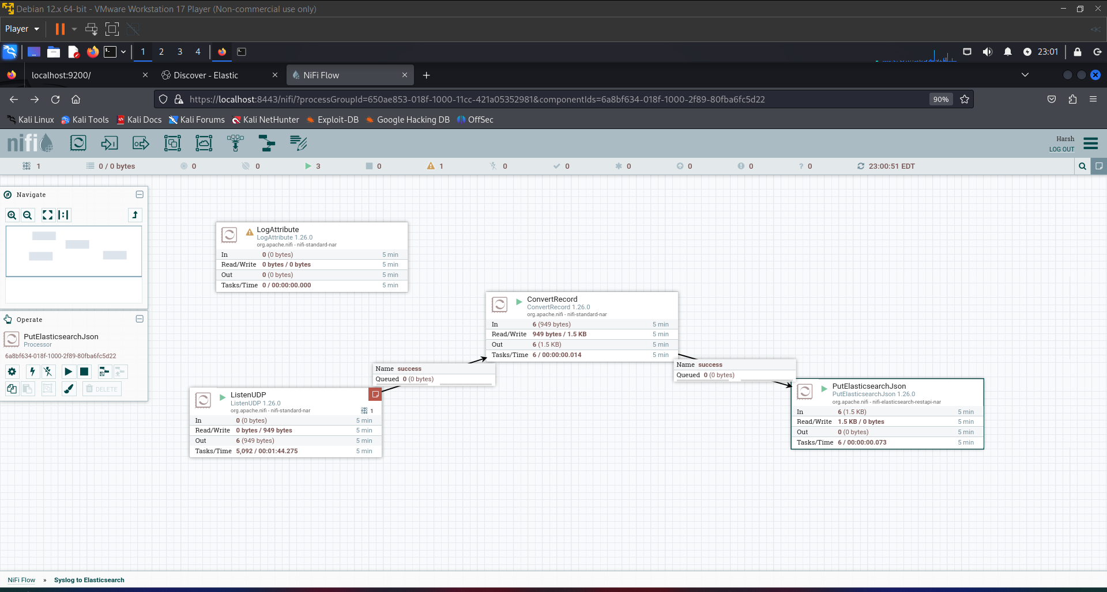

Open Kibana interface for data logs review.

